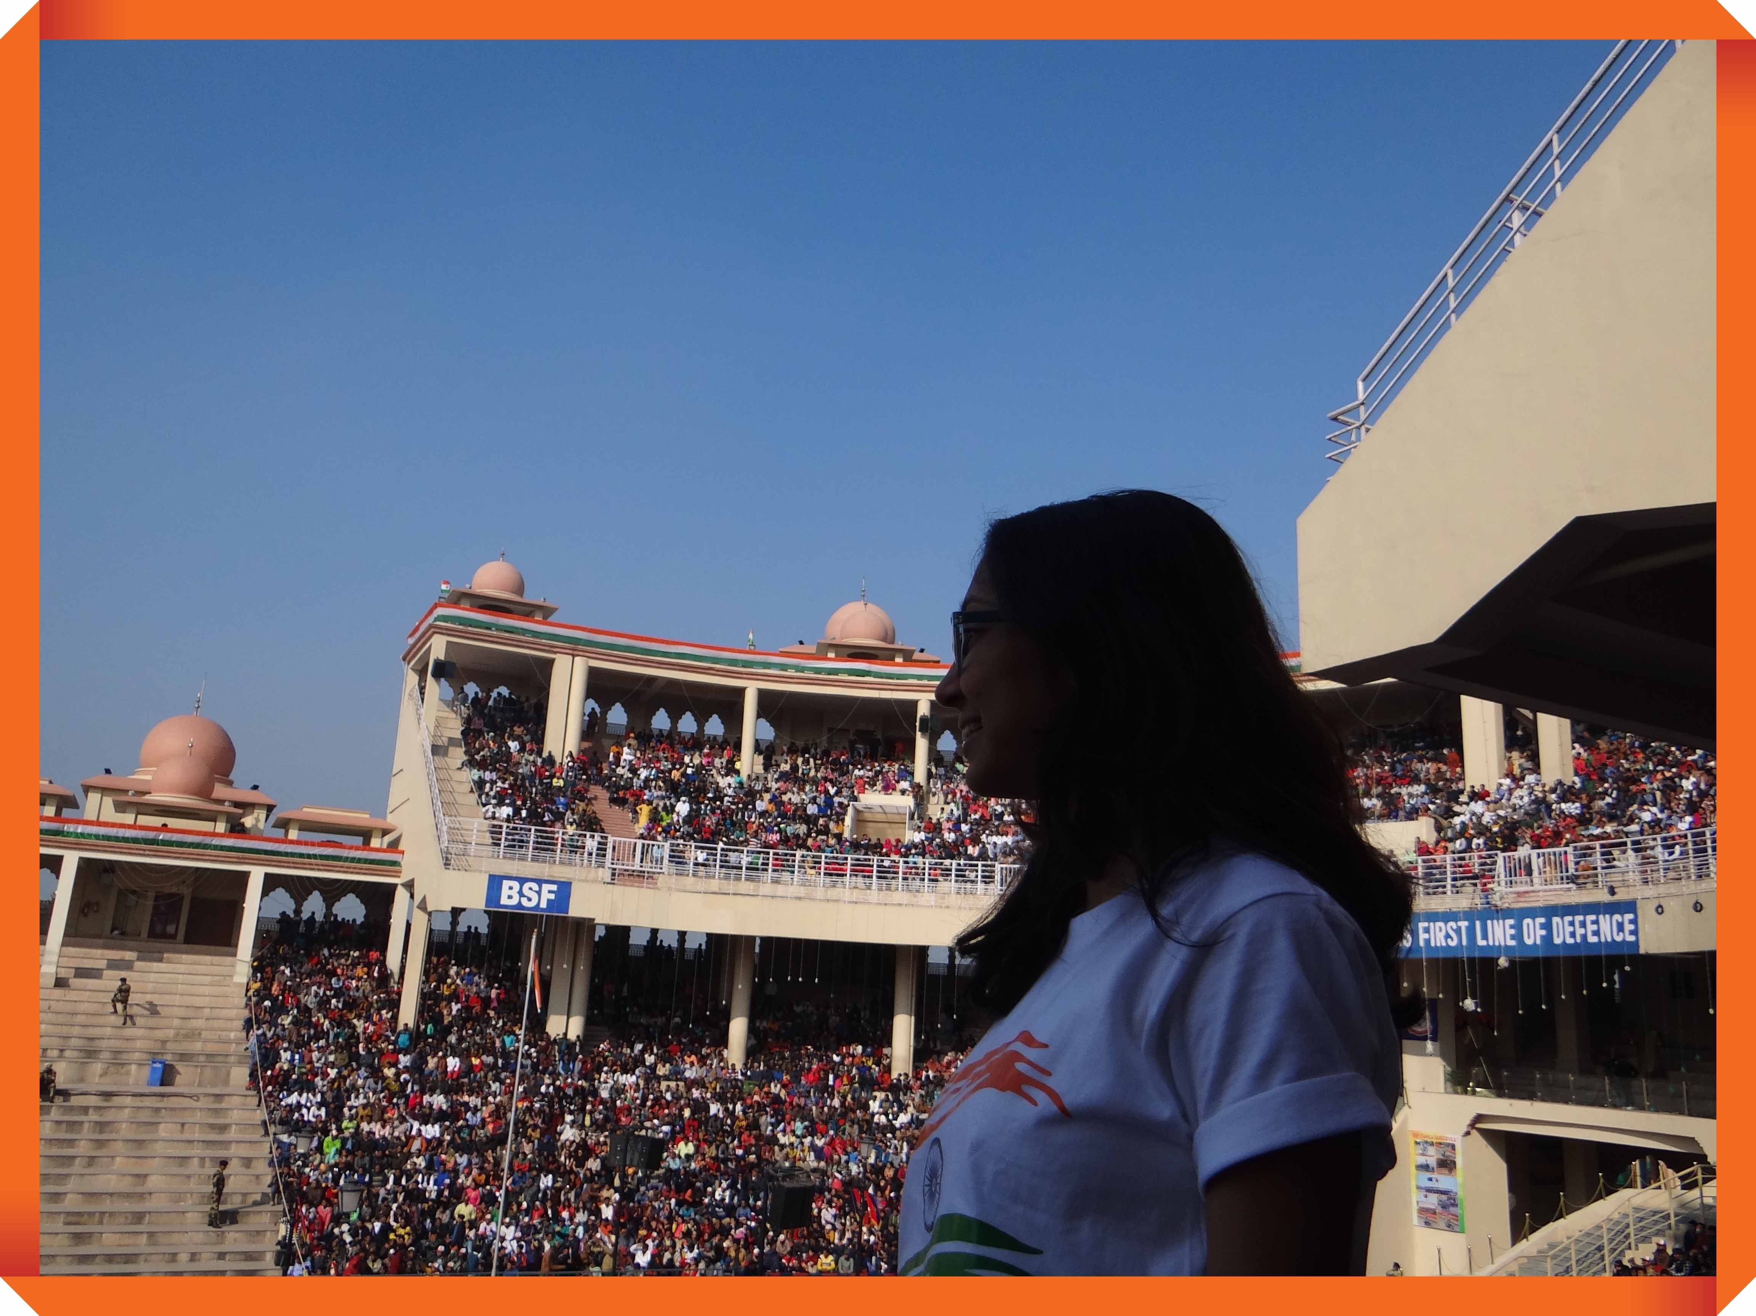

|  |
| --- |
| AMRITSAR  2019 |
|  |
| JAN 26  .  Authored by: Aditi Patel |



# Day 1

|  |
| --- |
| Landing in Amritsar! We reached the Chhatrapati Shivaji international airport, Mumbai, Maharashtra at 9 we had some lunch at the GVK lounge and board in our flight. It was 2hr 25min flight to Amritsar. When we reached ATQ Airport the temperature was 6°C and that was something that we experienced after a long time as compared to Mumbai's humid climate. It was indeed a welcome change, though we were prepared for it.  When you reach Amritsar airport, you can take a cab from the airport (OLA or UBER) or you can take a taxi from outside the Amritsar airport (Sri Guru Ram Das Je International Airport, Amritsar). My suggestion is please don't use the Google maps for the direction because we had stuck in near parking, as taxis don't go to some areas so we had to drop the taxi and take a rickshaw to reach our hotel.  After we reached our hotel we relaxed for some time and had some food, then we went to see the golden temple at night and it was truly a mesmerizing view that can flabbergast oneself. After the visit dinner time, we had many options for dinner near the golden temple-like Dominos Pizza, McDonald's, etc. and it is also a shopper’s stop, all the shopping is near the golden temple. |
| *“Live with no excuses and travel with no regrets”*  *~ Oscar Wilde* |
|  |

# Day 2

|  |
| --- |
| Visiting Jallianwala Bagh! Jallianwala Bagh is a public garden in Amritsar. It resembles a memorial of national importance, established in 1951 by the Government of India, to commemorate the massacre of peaceful celebrants including unarmed women and children by British occupying forces, on the occasion of the Punjabi New Year on 13 April 1919. Colonial British Raj sources identified 379 fatalities and estimated about 1100 wounded. Civil Surgeon Dr. Smith indicated that there were 1,526 casualties. The true figures of fatalities are unknown but are very likely to be many times higher than the official figure of 379.  The 6.5-acre (26,000) garden site of the massacre is located in the vicinity of the Golden Temple complex, the holiest shrine of Sikkim.    The memorial is managed by the Jallianwala Bagh National Memorial Trust, which was established as per the "Jallianwala Bagh National Memorial Act". Act No. 25 of 1 May 1951. Retrieved 10 August 2016.  The next day, after breakfast, we went to Jallianwala Bagh. It is a very good place for the historic event that had to occur in India, Udham Singh plays a very important role for the historic event that had happened, you will get to know everything about Udham Singh in the movie releasing soon. After the visit we went for shopping for Punjabi suits and some winter clothes winter wear clues in Punjab are very cheap and has varieties of clothes for shopping.  Till the evening we were shopping and during shopping, there were sweet potato we could find everywhere, we had dinner in dominos and then back to the hotel. |
| *“Life is either a Daring Adventure or Nothing at all”*  *~ Helen Keller* |
|  |

# Day 3

|  |
| --- |
| Visiting Attari Border! The morning we had our breakfast, took some rest and left for the Attari border. On the way we had our lunch at the Halevi. We were forced to go back to take the passes for the VIP seats and the evening we spend at the Atari border was so very astonishing, as it was 26th January there were shows like Punjabi dance, dance by Varun Dhawan for the dance 3 movie shoot, the first line of border songs was played and the program goes on till evening 6 which made all spectator gratified. We clicked some of the pictures and we were back near our hotel for dinner  At the Haveli hotel, there were wall painting and a structure created by some artist of the event that happened in Punjab (movie Kesari) |
| *“Take Only Memories, Leave Only Footprints”*  *~ Chief Seattle* |
|  |

# Day 4

|  |
| --- |
| Visiting Amritsar Haveli! We took a rent car and when to the Amritsar Haveli in New Amritsar. It is pure Punjabi authentic architecture they even had a restaurant inside huge and beautiful ambiance food that was very delicious, I highly recommend to have Lassi and Paneer Pakodas. They even had an open street food, where you get cutting chai and snacks if you want to go there in the afternoon for lunch. You can spend the entire day there till evening with lot of games and places to take pictures inside as well. |
| *“Traveling – It Leaves You Speechless, Then Turns You into a Storyteller.” – Ibn Battuta* |
|  |

Cya :)